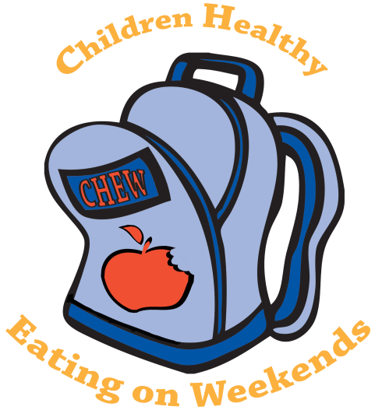
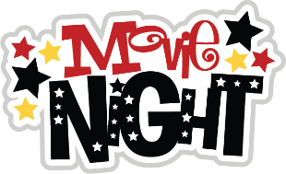
Parents’ Night Out at
Parkwood Elementary
For our CHEW Program
When: Friday, February 12, 2016 Time: 5:00-8:00pm

Cost: $10 Donation for CHEW Program (checks made out to PES)
(additional children in the same family are ½ price-$5)
includes babysitting, movie, dinner, and popcorn for the movie

Movie : Monsters University or Games/Crafts: Children who do not want to
watch the movie can make Valentine’s Day
cards, play games, or just talk with friends.

Only current Parkwood Elementary students are permitted to attend.
PLEASE RETURN NO LATER THAN WEDNESDAY, February 10th

Enjoy a few hours out and help support a great cause!

My child(ren), has/have my permission to attend the Parkwood Parents’ Night Out on Friday, February 12th from 5:00-8:00pm. I understand that I must give contact numbers for where I can be reached that evening from 5:00-8:00pm in order for my child to attend. I will pick up my child PROMPTLY at 8:00. The cost is $10.00 for the first child and $5.00 each for additional siblings. (cash or checks must be included with this permission slip)
Parent/Guardian Signature: ________________________________________________________

Parent Contact Numbers: __________________________________________________________

Emergency Contact Names & Numbers_____________________________________________

Child/Children Attending:

Name________________________________ Teacher: ____________________________
Name________________________________ Teacher: ____________________________
Name________________________________ Teacher: ____________________________

Turn Money and Permission Slip in to Mrs. Dedmond by February 10th at 3:00pm

